Children of Lir in the Garden of Remembrance

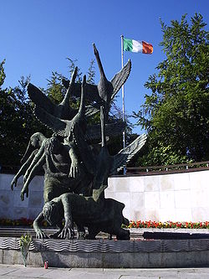

Swans soar towards freedom

