Mannanan MacLir rides his chariot over the sea

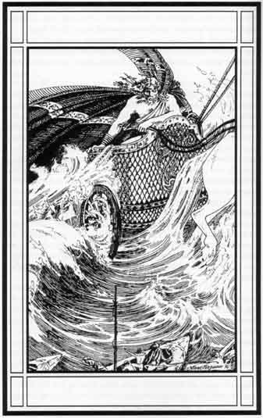

Crest on Manannan’s Shield

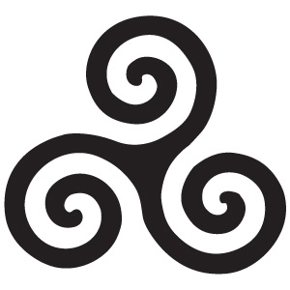
Manannans Magical Items
Manannán wore a magical cloak made from the morning mist and the splash of white foam off the waves. It’s colours changing like the sun from blue-green to silver, and again to purple. He could call up the mists at will and wrap himself in them so as not to be seen and then surprise his enemies with the sudden-ness of his attack. He wore a flaming helmet and kept his sword ‘Fragarach’ or ‘the Answerer’ in his hand. 'Fragarach' was fatal to those who it struck and so terrified those that opposed it, that it took all their strength away. He rode a giant sea-horse, called ‘Aonbarr of the flowing mane’. Aonbarr would pull Manannan’s chariot over the white –topped waves of the sea, and on land through fields of purple flowers.

Mananann’s Blessing

Little Manannan, son of Lir, who blessed our land,
Bless us and our boat, well going out
And better coming in with living and no dead in the boat.

Entreaty to Manannan MacLir
Flaming helm upon your head,
Fragarach, the Retaliator, in your hand.
Manannan MacLir,
of the Tuatha De Dannan.
God of Waves and Mists,
Defender of the Celts,
Guardian of the Blessed Isles.
Ruler of Mag Mell, The Plain of Joy.
Accept my humble offering, my rent.
I bring before you,
bundles of meadow grass, reeds and flowers,
for to feed your noble steed, Aonbarr,
who gallops over land and sea.
Grant us your protection,
and your blessing.
Show me the path,
touch me with your gifts.
Grant me the magic of your music,
and allow me to weave the mists
about my land, my people,
once more,
that I may protect them
from those who would destroy us,
would destroy our ways.
And should I fail in that,
guide our souls to the Blessed Isles,
to live with you forever,
on the Plain of Joy,
or below the waves.

