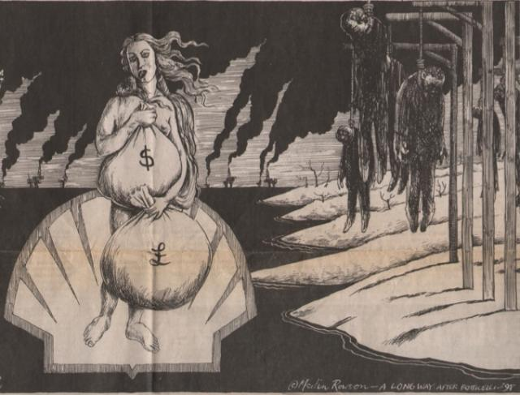

Unloveable Shell, the Goddess of Oil

