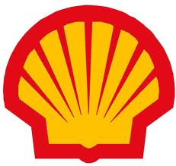
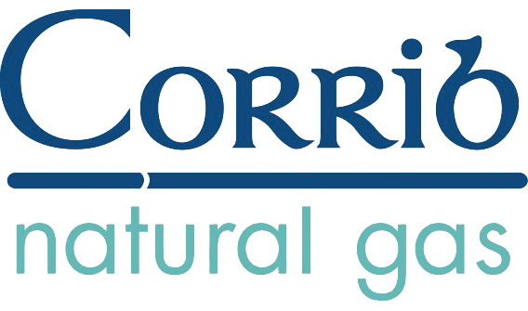
Multiple choice Corrib Gas Fun Quiz
Please circle either A, B or C to each of the following questions

(You may ask our representative for help at any time during the presentation)

ECONOMICS

- How much gas will Corrib supply to Ireland?
- 60% of Ireland’s gas needs for 20 years
- At peak production it could supply up to 60% of Irelands consumption, but this high rate only lasts a couple of years before the terminal decline of the well, which could take up to for 20 years
- It may not matter - as owners, Shell, Statoil and Vermillion are under no obligation to supply the Irish market

- How will Corrib affect the price we pay for gas?
- When Corrib comes online, gas will be cheaper because article 10 of the Constitution says we own the gas.
- The Price will stay the same.
- Corrib will probably make gas more expensive. If Corrib gas displaces gas imported via the UK, less will flow through the interconnector. The interconnector owners will raise the levy per unit to maintain their current income. The exporting gas owners will raise the price per unit of gas to the consumer to meet their higher transmission costs. Corrib gas will be traded at this new higher market rate.

- How much tax will be paid on Corrib?
- 78% - just like Norway
- 25% - lower than average for oil and gas producing countries
- None at all – because of terms and conditions brought in by Minister for Energy Ray Burke in 1987 and Bertie Ahern in 1992.

ENVIRONMENT

- How does Shell influence policy makers and planners?
- We just submit our plans and hope for the best
- “Suitably placed” people are always helpful
- We got a meeting with then Taoiseach Bertie Ahern in 2003 after An Bord Pleanala refused planning for the refinery and then a meeting with a senior planner

- How do you prevent harming the environment?
- The project is good for the environment because gas is less harmful than coal
- We plan our projects to avoid environmentally sensitive areas
- We are tunnelling straight through Sruwaddacon Estuary a Special Area of Conservation...

- Is it not dangerous to place a refinery in the catchment of the local drinking water supply reservoir?
- We have mitigation measures in place
- The Scottish EPA forbid it
- Shell already polluted it with aluminium during construction so we may as well work away

- When will the project be completed?
- 2003 was the original estimate...
- 2014/2015 all things going well
- The damaging effects of the project will last for generations

SOCIAL IMPACTS

- How do you deal with people who object to the project?
- Everyone agrees with the project as it stands
- There were some objections but we’ve modified the project to address these concerns
- Buy loads of booze for the Gardai and leave them at it

- How much money did Shell spend on alcohol for to bribe the Gardaí
- None. OSSL - the former contractor alleging this are making it up
- The odd bottle of whiskey at Christmas for the Superintendent
- E35,000 worth in one shipment alone to Belmullet Garda station in 2007

Who are the Rossport 5?
- Mayo’s latest boy-band
- Eco-warriors who were looking to pick a fight with Shell
- Four farmers and a retired school teacher living in Rossport Co. Mayo

- Why were the Rossport 5 jailed in 2005?
- They were just causing trouble
- They were against progress
- They wouldn’t leave Shell put an unprecedented high pressure, raw gas pipe through their land next to their homes

- Why are there no Shell or Statoil stations in Ireland?
- The recession
- We decided to concentrate on our core business
- Our stations were boycotted and picketed since the Rossport 5 were jailed in 2005. In 2008 because of the impacts of the boycott we sold out, rebranding as Topaz

- How do you feel about the Garda baton charge on peaceful protestors in 2006 to end the year and a half refinery site blockade?
- Good - People have a right to go to work
- Not great – Men, women and children were beaten – but I have to get to work
- Bad – Local fishermen at work were repeatedly arrested on the sea taken ashore and released without charge in 2008 and again in 2009 to clear Broadhaven Bay for the Solitaire, Shell’s contracted pipe-laying ship.

- How much violence is needed to push through a dangerous unwanted project like Corrib?
- None - the project is well received by the locals and nation alike.
- Some private Security
- 300 Gardaí, two navy gun boats, Garda helicopter, 200 private security in 2009 alone

SAFETY

- What pressure will the pipeline be at
- 4bar – like urban pipeline
- 60bar like a transmission pipeline
- 100bar in the onshore section, 150bar in the offshore section... we really want to run it up to 345bar...

- What is in the gas?
- Pure methane natural gas
- It’s almost pure - but that’s what the refinery is for
- A corrosive mixture of methane, water & heavy metals...

- What kind of pipes are being used
- New thick steel pipes
- Pipes we bought at the start of the project but they’re in good shape
- We’ll use the pipes that have been rusting away in Killybegs for the last decade

- What is the kill- zone around the pipeline in the case of worst case scenario accident?
- It’s a thick walled pipeline – it can’t fail
- 236m, provided that exposed individuals can get to safety within 10 seconds, walking away from the heat radiation.
- A separation distance of at least 500 metres from dwellings would be more appropriate than that currently proposed. The effect of a rupture could be similar to that of a tactical nuclear weapon

- What do if my I have to travel towards the heat radiation to get to shelter?
- It’s a thick walled pipeline – it can’t fail
- Jump in the bog
- You’re in Mayo - enjoy the high temperatures while you can

- How safe is it to work for Shell?
- Good – “safety is our number one priority”
- Ok - we only had one fatality last year
- Bad – our emphasis is on our safety record – not safety itself. There is huge pressure on everyone to cover up accidents and breaches.

- What is Shell’s safety record like around the world?
- We work to the highest safety standards
- There have been some problems in the past but we’re more safety-conscious now.
- Shell’s North Sea rigs operated a Touch F*** All policy in order to keep production going, virtually ensuring accidents would happen

- What is the Land Fall Gas Installation at Glengad beach?
- It’s a tried and tested safety valve – to make the project extra safe
- It’s never actually been built before but it will guarantee that the onshore gas pipeline stays under 100bar pressure
- It was tacked on to the project after we were forced to give a maximum operating pressure for the onshore pipeline. Because it increases complexity, it makes Glengad Beach the most dangerous part of the whole project

RESULTS!
- If you answered mostly “A” then you are well on the way to becoming a Shell employee – well done!
- If you answered mostly “B” then you need to restrict your media consumption to approved Shell literature, or any publications by the Independent News and Media Corp.
- If you answered “C” to any of the above questions then you’ve probably actually been to the affected area yourself – fair play!

